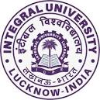

**Integral University, Lucknow**

**Department of Chemistry**

**Elocution Competition**

**On**

**Role of Education in National Integration**

**29th October, 2021**

To commemorate the 146th Birth Anniversary of Sardar Vallabhbhai Jhaverbhai Patel, first [Deputy Prime Minister of India](https://en.wikipedia.org/wiki/Deputy_Prime_Minister_of_India), the department of Chemistry in collaboration with Physics, Environmental Science and Mathematics & Statistics departments observed National Integration Day on 29th October, 2021. An elocution competition on the theme “**Role of Education in National Integration” was organized in NLT-5 at 10:00 am.**  The medium of the elocution was both English and Hindi. Each participant was allotted 03 minutes’ time to express their views on the allocated topic. Overall the experience was very good and all the participants expressed their views with confidence. The winners were felicitated by Prof. A.R. Khan, Dean, Faculty of Science and Prof. M.A. Khalid, Dean, Student Welfare. The vote of thanks was proposed by Dr. M. Lohani, Associate Professor, Department of Chemistry. The event was judged by Dr. Seema Srivastava, Head, Department of Physics.

**EVENT AT A GLANCE**

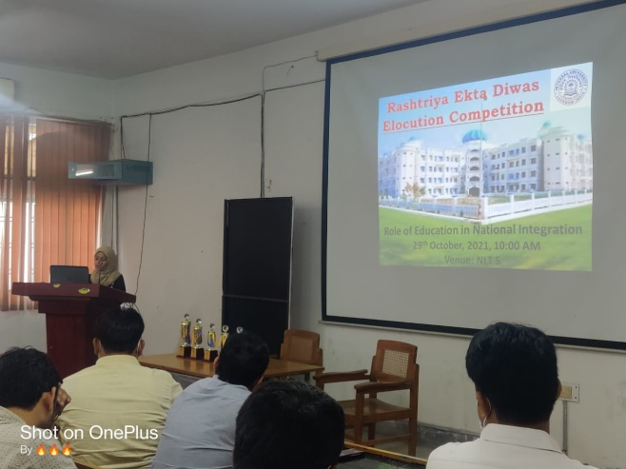 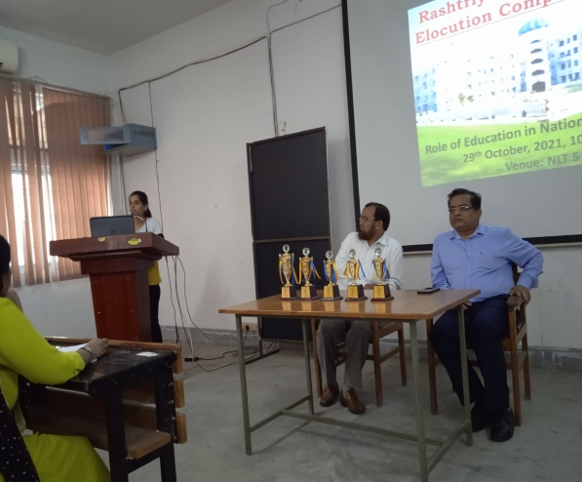

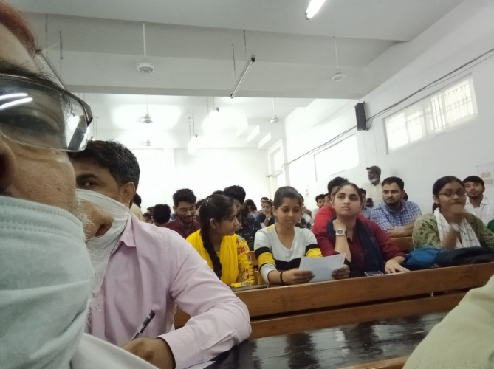 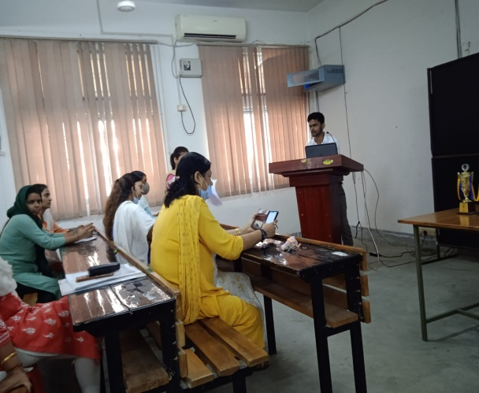

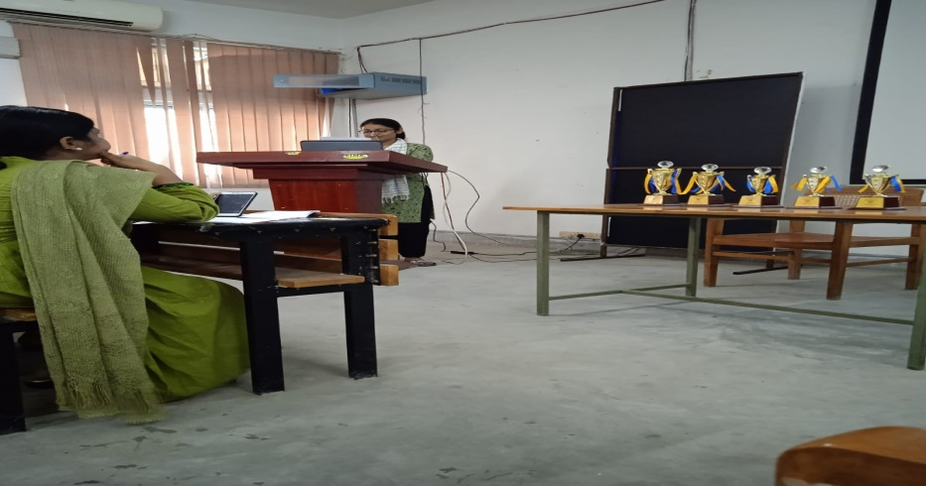

Submitted by:

Dr. M. Lohani, Dr. Tahmeena Khan